Grazioso Salvare Search & Rescue Dashboard
CS-340 Project Two
Christopher Plympton

Project Overview
This project involved the development of a full-stack client/server dashboard application for Grazioso Salvare, an international rescue animal training organization. The goal of the dashboard is to allow users to filter, identify, and visualize dogs that are strong candidates for search-and-rescue training using data provided by the Austin Animal Center.
The application connects to a MongoDB database and allows users to dynamically filter animals by rescue category:
Water Rescue
Mountain/Wilderness Rescue
Disaster/Individual Tracking
Reset (All Records)
The dashboard includes:
Interactive filtering controls
A dynamic data table
A breed distribution chart
A geolocation map displaying animal intake locations
The Grazioso Salvare logo
A unique identifier (Chris P)

Required Functionality
The dashboard successfully implements the following required features:
1. Interactive Filtering Controls
Radio buttons allow the user to filter dogs by rescue type. When a filter is selected:
The data table updates automatically.
The chart updates automatically.
The map updates automatically.
2. Interactive Data Table
The data table:
Displays records retrieved from MongoDB.
Supports sorting and filtering.
Allows row selection.
Updates dynamically based on selected rescue category.
3. Breed Distribution Chart
A histogram displays the count of breeds in the currently filtered dataset.
This provides quick visual insight into breed distribution for each rescue category.
4. Geolocation Map
A Leaflet-based map displays:
The latitude and longitude of selected animals.
A marker for the selected row in the data table.
A popup containing animal details.
The map dynamically updates when:
A different filter is selected.
A different row in the table is selected.

Proof of Functionality

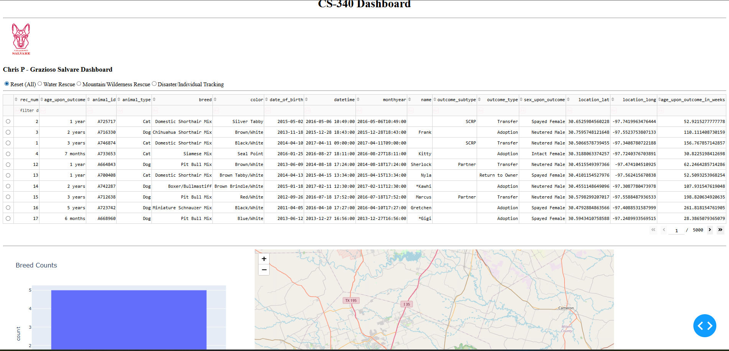

This page shows what appears when the dashboard first loads.

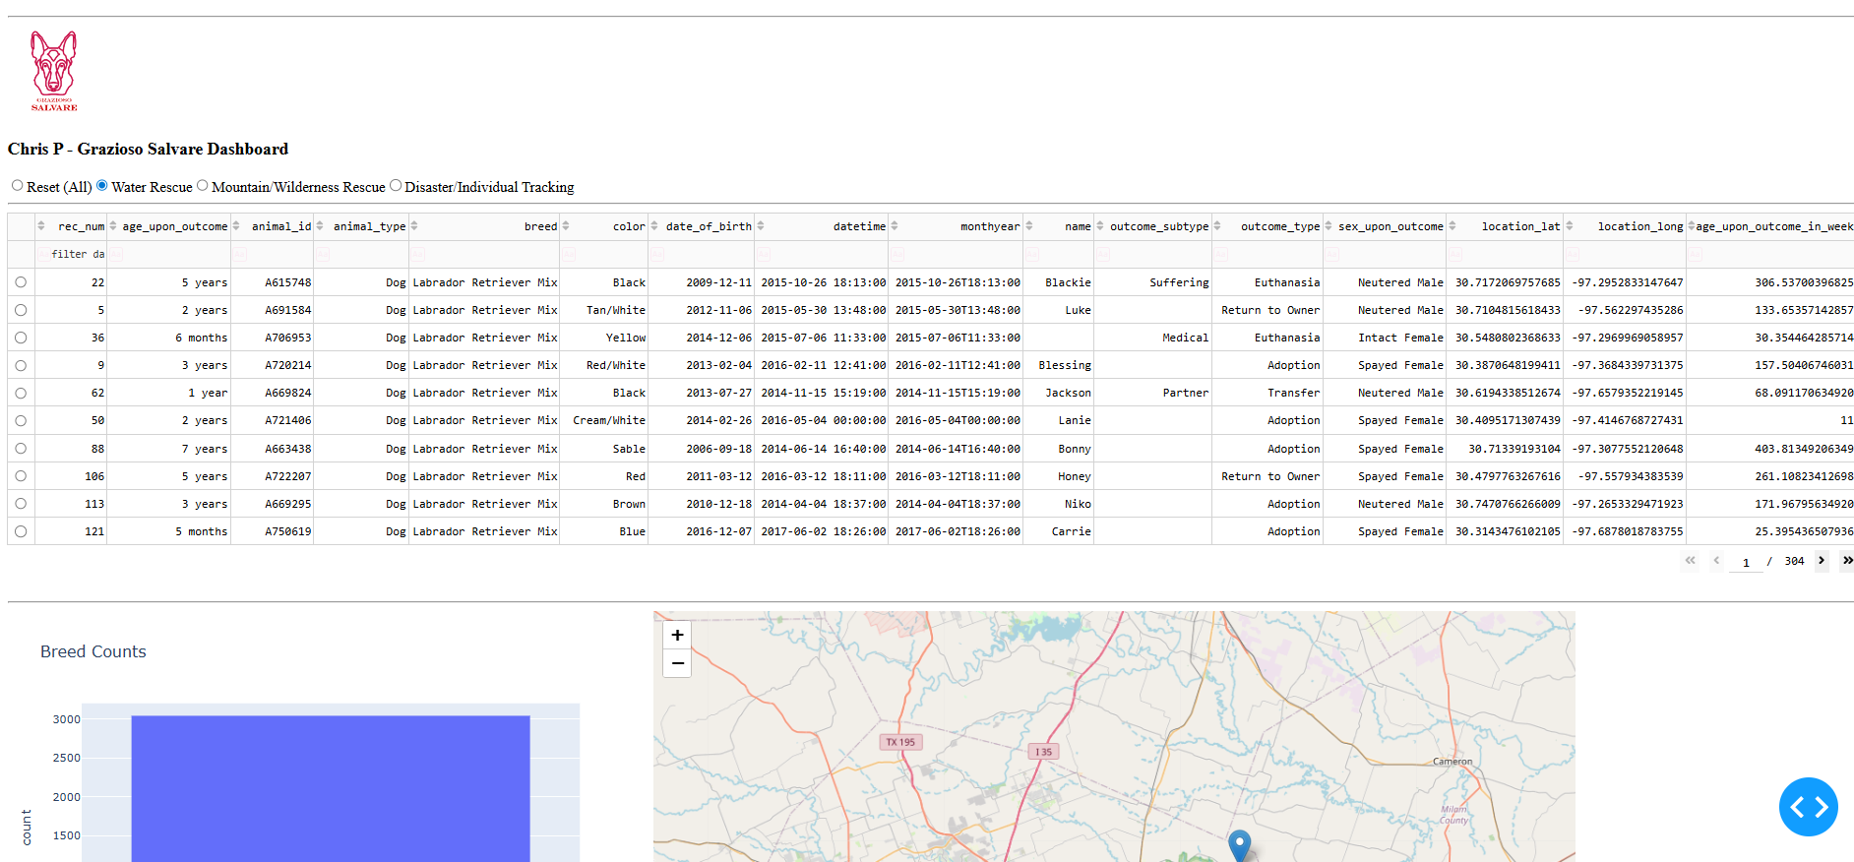

This shows the results under the Water Rescue tab. It also shows the locations.
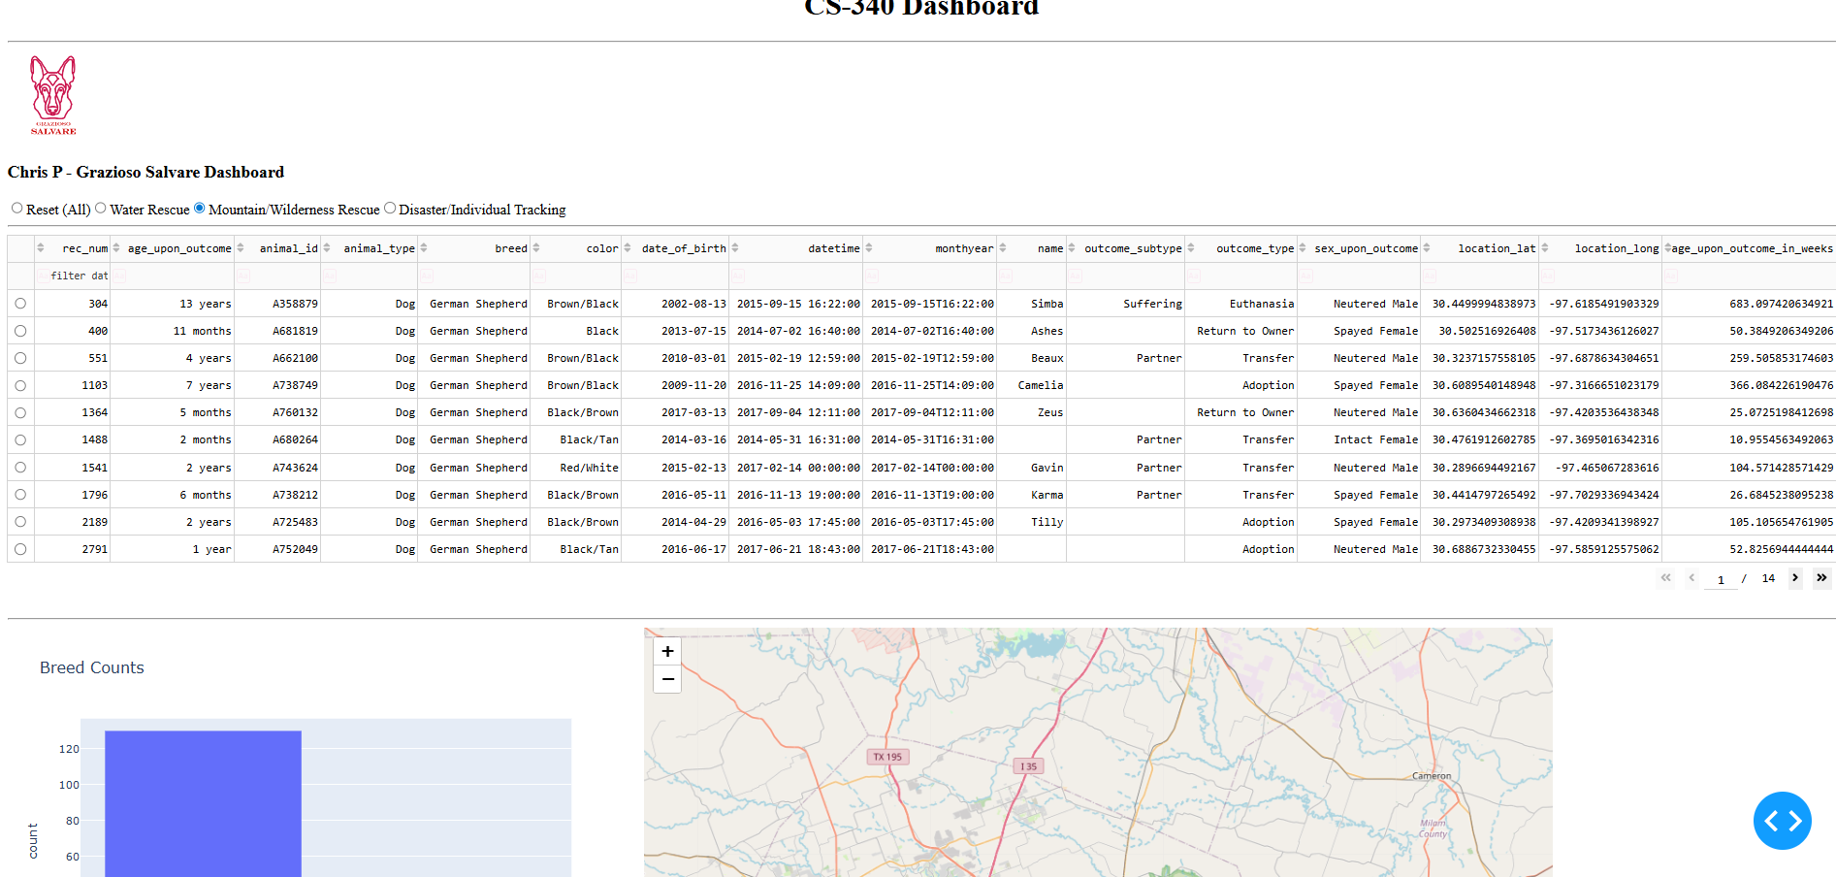
This shows the results under the Mountain Rescue tab as well as the locations.

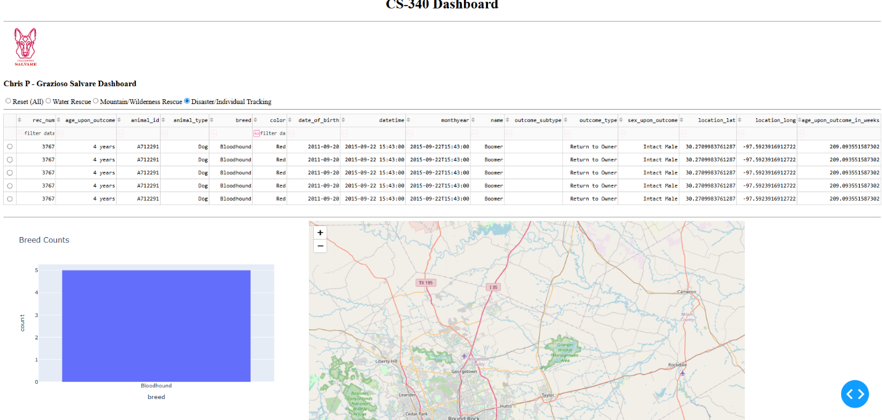
This shows the results under the Disaster/Individual Tracking tab as well as locations
You should include screenshots of:
Initial dashboard state (Reset selected)
Water Rescue filter applied
Mountain/Wilderness Rescue filter applied
Disaster/Individual Tracking filter applied
Reset applied again (if required by instructor)
Each screenshot should clearly show:
Logo
Your name
Filter selected
Updated data table
Updated chart
Updated map

Tools and Technologies Used
MongoDB (Model Layer)
MongoDB was used as the database component of the application. It was selected because:
It stores data in flexible JSON-like documents.
It integrates seamlessly with Python using dictionaries.
It supports fast querying with flexible filtering.
It allows dynamic schema, which works well with real-world datasets.
MongoDB enables easy CRUD operations using PyMongo in Python.

Python CRUD Module
A custom CRUD module was developed in Project One and reused in Project Two.
This module:
Connects securely to MongoDB.
Performs Create, Read, Update, and Delete operations.
Allows filtered queries to retrieve specific rescue categories.
This module acts as the Controller between the database and dashboard.

Dash Framework (View + Controller Layer)
The application follows the Model-View-Controller (MVC) design pattern. MongoDB serves as the model by storing and managing the animal records. The Dash dashboard layout and visual components act as the view. The callback functions within Dash serve as the controller, handling user input and coordinating communication between the interface and the database.
Dash was used to create the interactive web dashboard.
Dash was selected because:
It allows building interactive web applications entirely in Python.
It supports reactive callbacks.
It integrates well with Plotly charts.
It allows dynamic updating of UI components.
The dashboard uses:
dash_table for interactive data tables
plotly.express for charts
dash_leaflet for map visualization
dcc.RadioItems for filtering controls
Dash callbacks allow automatic updates between components.

Steps Taken to Complete the Project
Connected dashboard to MongoDB using the CRUD module.
Loaded all records into a Pandas DataFrame.
Created the dashboard layout including:
Logo
Title
Filter controls
Data table
Chart area
Map area
Implemented filtering logic for rescue categories.
Developed callback functions to:
Update table based on filter
Update chart based on filtered data
Update map based on selected row
Debugged authentication and callback errors.
Tested each filter and verified proper dynamic updates.
Captured screenshots demonstrating functionality.

Challenges Encountered
1. MongoDB Authentication Errors
Initially, authentication failed due to incorrect credentials and connection configuration.
This was resolved by verifying the MongoDB user credentials and ensuring the CRUD module connected properly.
2. Callback Errors in Dash
Several callback errors occurred due to:
Missing component IDs in layout
Handling None values in callbacks
Using column index positions instead of column names
These were resolved by:
Ensuring all component IDs existed in app.layout
Adding conditional checks for None
Referencing location_lat and location_long by name instead of index
3. Map Rendering Issues
The map initially failed due to missing or incorrectly referenced latitude and longitude values.
This was corrected by:
Dropping rows with missing coordinates
Using column names instead of numeric positions
Adding safe default row selection logic

How to Reproduce This Project
Open Codio environment.
Ensure MongoDB is running.
Verify the Austin Animal Center dataset is loaded.
Confirm the CRUD module (crud.py) is in the same directory.
Open ProjectTwoDashboard.ipynb.
Run all cells.
The dashboard will launch and display in the browser.

Resources Used
MongoDB Documentation: https://www.mongodb.com/docs/
Dash Documentation: https://dash.plotly.com/
Plotly Express Documentation: https://plotly.com/python/plotly-express/
Dash Leaflet Documentation: https://dash-leaflet.herokuapp.com/

